25 Editors - Outliner
Detailed table of content 2
Outliner 5
General hotkey functionality 6
Extended Functionality 6
Collections 6
Header - All Modes 7
Switch to Properties Editor / Outliner 7
Display Mode 7
View Menu 7
Search Field 9
Right Click Menus 9
Outliner Scene Operation 9
Outliner Data Operation 9
Collection 10
Object Menu 13
Outliner ID Data Operation 14
Outliner Animation Data Property 16
Level Restrictions 16
Scenes Mode 17
Collection Menu 17
Remove From Collection 18
Remove From all Unlinked Collections 18
Add selected To Active Collection 18
Remove Selected From Active Collection 18
Add Collection 19
Filter 19
View Layer Mode 19
Collection Menu 20
Remove From Collection 20
Remove From all Unlinked Collections 20
Add selected To Active Collection 21
Remove Selected From Active Collection 21
Add Collection 21
Filter 21
Sequence Mode 23
Sync Outliner Selection 23
Blender File Mode 23
Filter 23
Data API Mode 23
Header tools 24
Orphan Mode 24
Filter 25
Status column 25
Hotkey only functionality 25
Insert Keyframe - I 26
Delete Keying Set Keyframe - Alt I 26
Hide - H 26
Unhide - Alt H 26

Detailed table of content

Detailed table of content
Detailed table of content 2
Outliner 5
General hotkey functionality 6
Extended Functionality 6
Collections 6
Header - All Modes 7
Switch to Properties Editor / Outliner 7
Display Mode 7
View Menu 7
Show Active 7
Show One Level 7
Hide One Level 8
Expand / Collapse All 8
Show Hierarchy 8
Box Select 8
Select All 8
Deselect All 8
Invert Selection 8
Area 8
Horizontal Split 8
Vertical Split 8
Duplicate Area into new Window 8
Toggle Maximize Area 8
Toggle Fullscreen Area 8
Search Field 9
Right Click Menus 9
Outliner Scene Operation 9
Delete 9
Outliner Data Operation 9
Select 9
Deselect 9
Hide 9
Unhide 9
Select Linked 10
Collection 10
New 10
New Nested 10
Duplicate Collection 10
Duplicate Linked 10
Copy 10
Paste 10
Delete 10
Delete Hierarchy 10
Select Objects 10
Deselect Objects 10
Instance to Scene 11
Unlink 11
Visibility 11
Isolate 11
Show All Inside 11
Hide 11
Set Color Tag 11
ID Data 11
Unlink 11
Make Local 11
Add Library Override 12
Make Single User 12
Delete 12
Remap Users 12
Copy 12
Paste 12
Add Fake User 12
Clear Fake User 12
Rename 12
Select Linked 12
Object Menu 13
Select 13
Select Hierarchy 13
Deselect 13
Copy 13
Paste 13
Delete 13
Delete Hierarchy 13
Unlink 13
ID Data 13
Unlink 13
Make Local 13
Make Single User 14
Delete 14
Remap Users 14
Copy 14
Paste 14
Add Fake User 14
Clear Fake User 14
Rename 14
Select Linked 14
Outliner ID Data Operation 14
Unlink 14
Mark Asset 14
Clear Asset 15
Make Local 15
Make Single User 15
Delete 15
Remap Users 15
Add Library Override 15
Add Library Override Hierarchy 15
Convert Proxy to Override 15
Reset Library Override 15
Reset Library Override Hierarchy 15
Resync Library Override Hierarchy 15
Delete Library Override Hierarchy 15
Copy 16
Paste 16
Add Fake User 16
Clear Fake User 16
Rename 16
Select Linked 16
Outliner Animation Data Property 16
Clear Animation Data 16
Set Action 16
Unlink Action 16
Refresh Drivers 16
Clear Drivers 16
Level Restrictions 16
Selectability 17
Hide from Viewport 17
Hide from Render 17
Scenes Mode 17
Collection Menu 17
Move to Collection 17
Last Operator Move to Collection 18
Name 18
Link to Collection 18
Last Operator Link to Collection 18
Name 18
Remove From Collection 18
Remove From all Unlinked Collections 18
Add selected To Active Collection 18
Remove Selected From Active Collection 18
Add Collection 19
Filter 19
Restriction Toggles 19
Sort Alphabetically 19
Sync Selection 19
Show Mode Column 19
Search 19
Exact Match Search 19
Case Sensitive Search 19
View Layer Mode 19
Collection Menu 20
Move to Collection 20
Last Operator Move to Collection 20
Name 20
Link to Collection 20
Last Operator Link to Collection 20
Name 20
Remove From Collection 20
Remove From all Unlinked Collections 20
Add selected To Active Collection 21
Remove Selected From Active Collection 21
Add Collection 21
Filter 21
Restriction Toggles 21
Exclude from View Layer 21
Selectable 21
Hide in Viewport 21
Disable in Viewport 21
Disable in Renders 22
Holdout 22
Indirect only 22
Sort Alphabetically 22
Sync Selection 22
Show Mode Column 22
Search 22
Exact Match Search 22
Case Sensitive Search 22
Filter 22
Object State Filter 22
Invert 22
Sequence Mode 23
Sync Outliner Selection 23
Blender File Mode 23
Filter 23
Filter ID Type 23
Data API Mode 23
Header tools 24
Edit Menu 24
Keying Set Add Selected 24
Keying Set Remove Selected 24
Add Drivers to Selected 24
Delete Drivers for Selected 24
Set Keying set 24
Add keyframe 24
Remove keyframe 24
Orphan Mode 24
Purge 25
Filter 25
Filter ID Type 25
Status column 25
Hotkey only functionality 25
Insert Keyframe - I 26
Delete Keying Set Keyframe - Alt I 26
Hide - H 26
Unhide - Alt H 26

Outliner

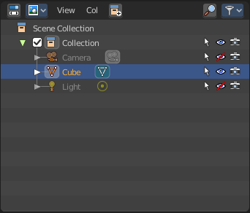
The Outliner is an editor where you can organize the data in your scene. It is in the View Layer mode basically a list of the available objects and data in the scene, which is organized in so called collections. Think of it as a container that carries the scene data. This also includes things like brushes, textures and materials.

The outliner not only lists the data. But you can modify the data in various ways. And it has more than one mode. We will go through them, one by one.

The outliner has some context menus that are available by a right click at an element. We will also cover them, one by one.

General hotkey functionality
There is some general hotkey functionality that works across the whole interface. And so it works in the outliner too.
Left click at an object selects it. When you select an object in the outliner, then it is also selected in the scene.
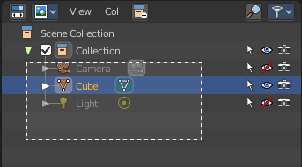
Dragging the mouse with left click box selects.

Like in the 3D view, Shift + LMB adds to the selection, or can remove the clicked object from the selection.
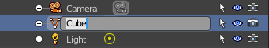
Ctrt+LMB enters the rename mode for the object. You can also double click at it. In both cases the text becomes editable.
You can drag objects into the hierarchy of other objects, and make them a child object by that.
You can navigate with the arrow buttons. Holding shift while navigating with the arrow buttons will extend the selection.
Delete hotkey deletes the selected items. Also selected collections.

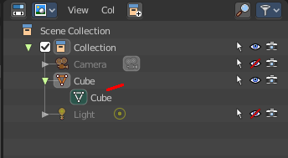
Extended Functionality
The outliner has some extended functionality in some modes.
Objects with an arrow sign at the left are hierarchical objects. Hierarchy can be expanded and collapsed by clicking at the + and - signs.
When you click at a data block of some object types object, like the mesh component for a mesh or a curve object, then you will jump from object mode into edit mode. And vice versa.

Collections
Collections are containers that can contain objects or anything else in the scene. They can also include collections, and are fully recursive.

Header - All Modes

The header content changes, dependent of the display mode. Here we list the elements that are available in all display modes.

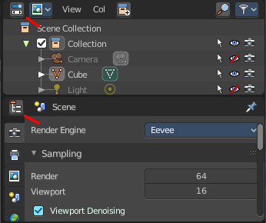
Switch to Properties Editor / Outliner
Sometimes you want to switch from Outliner to the Properties Editor, or vice versa. Since you sometimes don't have enough space for both, and end in dragging the borders of the editors around all the time. This two editors are connected by a menu that allows exactly that. A button in each header that switches to the other editor.

Display Mode
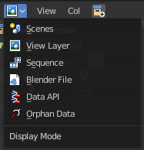
The Outliner has more than one purpose and workspace. In this drop down menu you can switch to different display modes. The available Modes are Scenes, View Layer, Sequence, Blender File, Data API and Orphan Data. We will cover their functionality in their own chapters.

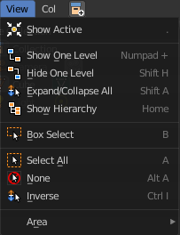
View Menu
The View menu contains general view related functionality.

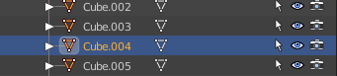
Show Active
Centers the view of the list to the active object.

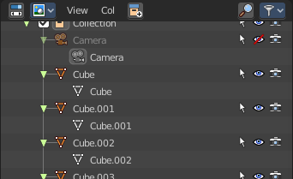
Show One Level
Expands the list hierarchy level by one.

Hide One Level
Collapses the list hierarchy level by one.

Expand / Collapse All
Expands or collapses all collapsed hierarchy. It's a toggle

Show Hierarchy
Open all object entries and close all others. For example, when you are in Scene view, and have the objects expanded, then the Show Hierarchy closes the objects hierarchy.

Box Select
Box select items in the list.

Select All
Select all items in the list.

Deselect All
Deselect all items in the list.

Invert Selection
Inverts the selection. Unselected list items becomes selected, selected list items becomes unselected.

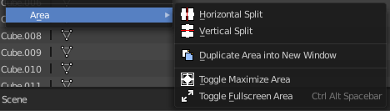
Area
Area is a menu with window related settings.

Horizontal Split
Splits the editor horizontally into two editors.

Vertical Split
Splits the editor vertically into two editors.

Duplicate Area into new Window
Creates a floating window out of the current editor

Toggle Maximize Area
Displays the editor maximized with menus.
To return to split view press hotkey Ctrl Up Arrow, or reuse the menu item in the View menu.

Toggle Fullscreen Area
Displays the editor maximized without menus.
To return from the full screen view press hotkey Alt F10, or use the little button that appears up right when you move the mouse in this corner.

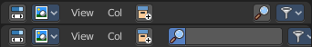
Search Field
Search for specific terms in the list. When the search term matches a name in the list, then the list will center at the first entry with the match.
This search field is collapsible, and closed by default to free some UI space.

Right Click Menus

The Outliner comes with various right click functionality, dependent at what data you right click.

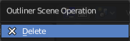
Outliner Scene Operation
This menu appears when you right click at a scene in Scene mode.

Delete
Deletes the currently selected scene.

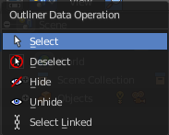
Outliner Data Operation
This menu appears at various object types and when you for example right click at the View Layer. It also appears at objects in Data API mode.
This menu is work in progress, the functionality is not implemented yet! You will get a warning!

Select
Select the current element.

Deselect
Deselect the current element.

Hide
Hides the current element.

Unhide
Unhides the current element.

Select Linked
Selects the linked elements.

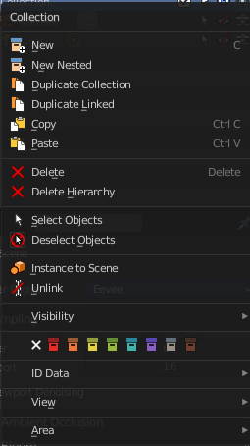
Collection
This menu appears when you right click at a collection. Clicking at a Scene collection will just give you a New menu item. Clicking at the Collection item lower in the hierarchy will give you a bigger menu then.

New
Create a new scene collection.

New Nested
Create a new nested collection. There is no difference. Both gets added in the selected collection as a child, and the functionality is the same. Ask the Blender developers what they did here.

Duplicate Collection
Duplicates the currently selected collection, all its children, objects and the object data.

Duplicate Linked
Recursively duplicate the selected collection, all its children and objects, including linked object data.

Copy
Copies the collection.

Paste
Pastes a copied collection.

Delete
Delete the collection. Objects in the hierarchy will remain.

Delete Hierarchy
Delete the collection. Objects in the hierarchy will be deleted too.

Select Objects
Select the objects in the collection.

Deselect Objects
Deselect the objects in the collection.

Instance to Scene
Instance selected collections to the active scene.

Unlink
Unlink selected collections from the active scene.

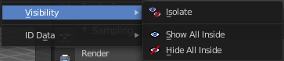
Visibility
Visibility is a sub menu with some visibility functionality. The greyed out menu items will become available when the functionality becomes available. For example, Show becomes available when something is hidden.

Isolate
Hide all but this collection and its parents.

Show All Inside
Reveals the collection and all its content.

Hide
Hides the collection.

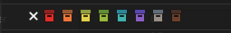
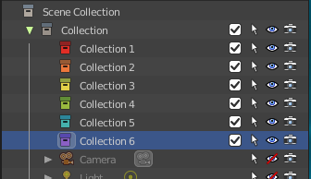
Set Color Tag
Give the collections a colored icon.

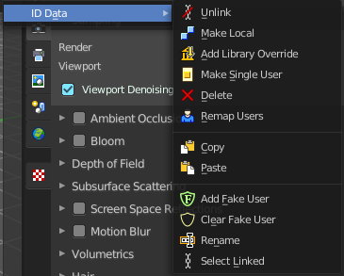
ID Data
Data related operations. Note that the tool tips are currently missing here.

Unlink
Does basically the same than delete. It unlinks all data, and removes the object from the scene.

Make Local
For appended or linked data. Makes the selected object a local copy in the current blend file.

Add Library Override
Add a local library override to this collection.
This tool works different from Make Override in the outliner. It does not iterate through the hierarchy of objects and collections based on the selection. But works just for the currently selected object.

Library Overrides is the new system designed to replace and supersede Proxies. Most types of linked data-blocks can be overridden, and the properties of those overrides can then be edited. When the library data change, unmodified properties of the override one will be updated accordingly.

Make Single User
For duplicated content. Makes the data block of the selected object a single user.

Delete
Not functional in all situations. In the orphan data mode you can remove objects with this.

Remap Users
Remaps the user of a data block to another one of the same type. This allows you to replace all usages of a material or texture by another one.

Copy
Copies the user data block.

Paste
Pastes a copied user data block.

Add Fake User
Adds a fake user to the selected object. Fake users is an odd concept to keep data in the scene even if it has no user somewhere. The fake user is then a dummy user so that the object is not deleted when saving the scene.

Clear Fake User
Removes the fake user from the selected object.

Rename
Rename the object in the outliner.

Select Linked
Selects all objects that are linked to the currently selected one.

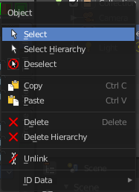
Object Menu
This menu appears when you click at an object type. A mesh, a lamp, a camera ...

Select
Selects the object.

Select Hierarchy
Selects the object and its hierarchy.

Deselect
Deselects the object.

Copy
Copies object.

Paste
Pastes copied object.

Delete
Deletes the selected object. Child objects gets unparented.

Delete Hierarchy
Deletes the selected object and all its child objects.

Unlink
Deletes the selected object.

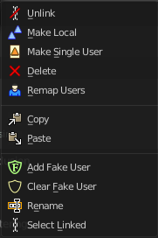
ID Data
Data related operations. Note that the tool tips are currently missing here.

Unlink
Does basically the same than delete. It unlinks all data, and removes the object from the scene.

Make Local
For appended or linked data. Makes the selected object a local copy in the current blend file.

Make Single User
For duplicated content. Makes the data block of the selected object a single user.

Delete
Not functional in all situations. In the orphan data mode you can remove objects with this.

Remap Users
Remaps the user of a data block to another one of the same type. This allows you to replace all usages of a material or texture by another one.

Copy
Copies ID data.

Paste
Pastes copied ID data.

Add Fake User
Adds a fake user to the selected object. Fake users is an odd concept to keep data in the scene even if it has no user somewhere. The fake user is then a dummy user so that the object is not deleted when saving the scene.

Clear Fake User
Removes the fake user from the selected object.

Rename
Rename the object in the outliner.

Select Linked
Selects all objects that are linked to the currently selected one.

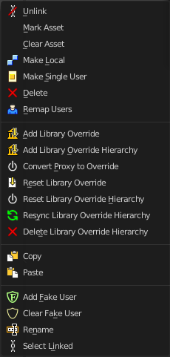
Outliner ID Data Operation
This menu appears when you for example click at the mesh component of a mesh object. It is the same content than the ID Data menu from the Object menu.

Unlink
Does basically the same than delete. It unlinks all data, and removes the object from the scene.

Mark Asset
Adds the object to the asset browser.

Clear Asset
Removes the object from the asset browser.

Make Local
For appended or linked data. Makes the selected object a local copy in the current blend file.

Make Single User
For duplicated content. Makes the data block of the selected object a single user.

Delete
Not functional in all situations. In the orphan data mode you can remove objects with this.

Remap Users
Remaps the user of a data block to another one of the same type. This allows you to replace all usages of a material or texture by another one.

Add Library Override
Add a local override to this operator.
Library Overrides is the new system designed to replace Proxies. Proxies are the historical way in Blender to allow some local editing of linked data-blocks.

Add Library Override Hierarchy
Add a local override to this operator and its hierarchy of dependencies.

Convert Proxy to Override
Convert a proxy to a full library override, including all its dependencies.

Reset Library Override
Reset this local override to its linked values.

Reset Library Override Hierarchy
Reset this local override and all its dependencies to its linked values.

Resync Library Override Hierarchy
Rebuild this local override and all its dependencies from its linked dependencies.

Delete Library Override Hierarchy
Delete this local override including its hierarchy of override dependencies. And relink its usages to the linked data.

Copy
Copies ID data.

Paste
Pastes copied ID data.

Add Fake User
Adds a fake user to the selected object. Fake users is an odd concept to keep data in the scene even if it has no user somewhere. The fake user is then a dummy user so that the object is not deleted when saving the scene.

Clear Fake User
Removes the fake user from the selected object.

Rename
Rename the object in the outliner.

Select Linked
Selects all objects that are linked to the currently selected one.

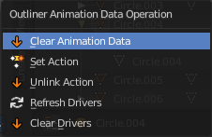
Outliner Animation Data Property
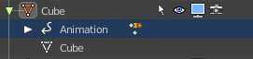
This menu appears with a right click at an Animation data.

Clear Animation Data
Removes the whole animation.

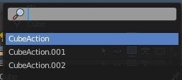
Set Action
Opens a popup menu where you can choose the action for this object.

Unlink Action
Removes the action.

Refresh Drivers
Refreshes existing drivers.

Clear Drivers
Removes existing drivers.

Level Restrictions
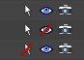
Some list items have so called level restrictions. You can click at them, and so exclude the object from specific things. You can make more level restrictions available in the filter settings, which will be covered below. The by default activated are:

Selectability
Makes the object unselectable in the viewport. Or disables it, in case of a collection for example.

Hide from Viewport
Hides the object from the Viewport.

Hide from Render
Excludes the object from rendering.

Scenes Mode
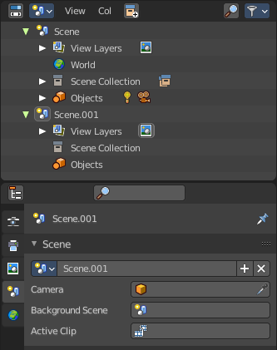
The Scenes mode starts one hierarchy higher than the default View Layer Mode. It shows all available scenes and their content.

Normally you work with one scene. And so the default starts with the View Layer mode of the scene. But you can create more scenes in the Properties Editor in the Scene tab.

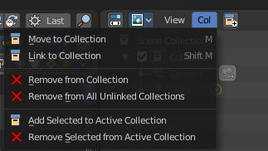
Collection Menu

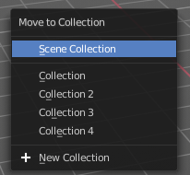
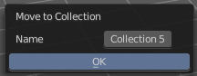
Move to Collection
Moves the selected object to a collection. The object is removed from the collection it was in.
By clicking at this menu item a popup will appear to choose the new collection. Allows also to create a new collection. Once done, the object will be moved to this new created collection.

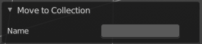
Last Operator Move to Collection

Name
Set a name for your new collection. When you haven't created a new collection, then this name stays blank.

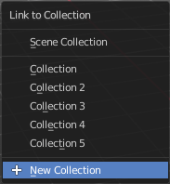
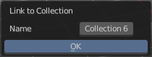
Link to Collection
Links the object to a collection. The object remains in the collection it was in.

By clicking at this menu item a popup will appear to choose the collection. Here you can also create a new collection. Once done, the object will be linked to this new created collection.

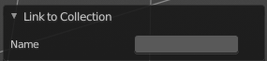
Last Operator Link to Collection

Name
Set a name for your new collection. When you haven't created a new collection, then this name stays blank.

Remove From Collection
Objects can be in more than one collection. Remove from collection removes the selected object from the current collection.
When the object is in no collection anymore, then it gets removed.

Remove From all Unlinked Collections
Objects can be in more than one collection. Remove from all unlinked collection removes the selected object from all unlinked collections.
When the object is in no collection anymore, then it gets removed.

Add selected To Active Collection
Objects can be in more than one collection. Adds the selected object to the active collection.

Remove Selected From Active Collection
Objects can be in more than one collection. Removes the selected object from the active collection.
When the object is in no collection anymore, then it gets removed.

Add Collection
Add a collection inside of the current selected collection.

Filter
Options and filter settings.

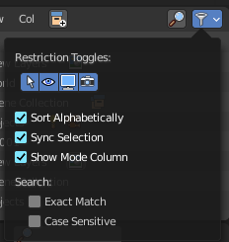
Restriction Toggles
Enable or disable further level restrictions. Note that these toggles shows when you expand a scene hierarchy. Scenes itself have no such toggles.

Sort Alphabetically
Sorts the content of the outliner in alphabetically order.

Sync Selection
Synchronize the selection between outliner and 3d view.

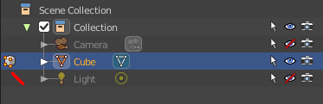
Show Mode Column
Display the Mode column at the left. When you are not in object mode, but in edit mode, or in vertex paint mode etc. , then a mode icon is displayed at the left of the object that you currently edit.

Search

Exact Match Search
The search result must fit exactly. For example, when you search for cam, then a camera should not display as a search result.

Case Sensitive Search
Search case sensitive.

View Layer Mode
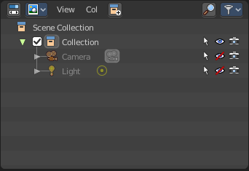
The view layer mode shows the content of the current View Layer. This is the default mode.

Collection Menu

Move to Collection
Moves the selected object to a collection. The object is removed from the collection it was in.
By clicking at this menu item a popup will appear to choose the new collection. Allows also to create a new collection. Once done, the object will be moved to this new created collection.

Last Operator Move to Collection

Name
Set a name for your new collection. When you haven't created a new collection, then this name stays blank.

Link to Collection
Links the object to a collection. The object remains in the collection it was in.

By clicking at this menu item a popup will appear to choose the collection. Here you can also create a new collection. Once done, the object will be linked to this new created collection.

Last Operator Link to Collection

Name
Set a name for your new collection. When you haven't created a new collection, then this name stays blank.

Remove From Collection
Objects can be in more than one collection. Remove from collection removes the selected object from the current collection.
When the object is in no collection anymore, then it gets removed.

Remove From all Unlinked Collections
Objects can be in more than one collection. Remove from all unlinked collection removes the selected object from all unlinked collections.
When the object is in no collection anymore, then it gets removed.

Add selected To Active Collection
Objects can be in more than one collection. Adds the selected object to the active collection.

Remove Selected From Active Collection
Objects can be in more than one collection. Removes the selected object from the active collection.
When the object is in no collection anymore, then it gets removed.

Add Collection
Add a collection inside of the current selected collection.

Filter
Options and filter settings.

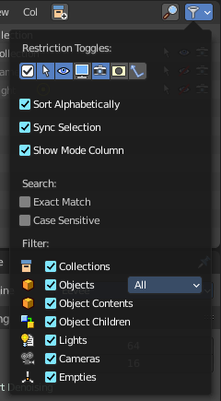
Restriction Toggles
Enable or disable further level restrictions. To make the changes permanent you would have to save the startup file. This settings is part of the layout.
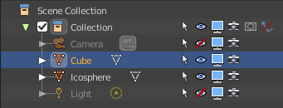

Exclude from View Layer
include / Exclude the collection from the view layer.

Selectable
Make the object selectable / unselectable.

Hide in Viewport
Show or hide the object in the viewport.

Disable in Viewport
Enable or disable the object in the viewport.

Disable in Renders
Enable or disable the object in the rendered result.

Holdout
Mask out objects in the collection from view layer.

Indirect only
Make the objects in the collection just distribute indirect lighting to the layer.

Sort Alphabetically
Sorts the content of the outliner in alphabetically order.

Sync Selection
Synchronize the selection between outliner and 3d view.

Show Mode Column
Display the Mode column at the left. When you are not in object mode, but in edit mode, or in vertex paint mode etc. , then a mode icon is displayed at the left of the object that you currently edit.

Search

Exact Match Search
The search result must fit exactly. For example, when you search for cam, then a camera should not display as a search result.

Case Sensitive Search
Search case sensitive.

Filter
Shows or hides the object and data types. The names should be self explaining.

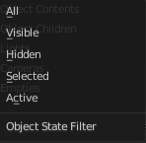
Object State Filter
Shows or hides objects by its state.

Invert
Inverts the object state filter.

Sequence Mode
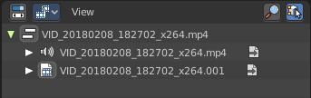
This mode lists the loaded files when you work with the sequencer layout and have video material loaded.

Sync Outliner Selection
Keep the selection in synchronization with the other editors. 3D View and VSE.

Blender File Mode

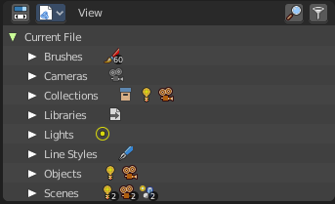
This mode lists the whole content of the current Blender file. It includes also things like the default brushes, which comes from the startup defaults.

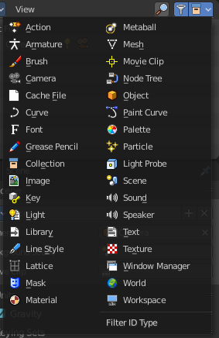
Filter

Enable a filter to display a specific data type. You can just filter by one data type at a time. The rest will be hidden.

Filter ID Type
The menu to choose the data type that should be displayed.

Data API Mode

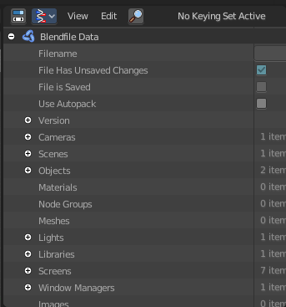
Displays Low Level Blender data and its properties.
This view also reveals some properties. Like File is Saved or Use Autopack.
When no keying set is defined then you will get a No Keying set Active message instead of the Keying set element.
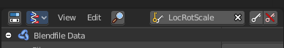

Header tools

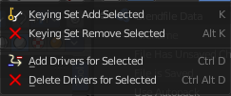
Edit Menu

Keying Set Add Selected
Add a keying set to the selected object.

Keying Set Remove Selected
Remove the keying set from the selected object.

Add Drivers to Selected
Add a driver to the selected object.

Delete Drivers for Selected
Delete a driver from the selected object.

Set Keying set
Choose a keying set.

Add keyframe
Adds a keyframe for the selected element.

Remove keyframe
Removes the current keyframe from the selected element.

Orphan Mode

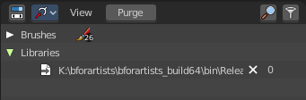
Bforartists has a special system to treat not longer used data. Unused data will normally remain in the scene as long as you haven't saved it and reloaded it. Means delete does not immediately remove a mesh completely from the scene for example. It will be orphan data now. Until you save and reopen the scene. The cleanup process happens at saving the blend file.

The Orphan Mode allows you to clean up the unused data without to save and reload the blend file. It lists all data that has no user in the scene. This includes the standard brushes from the startup configuration. Don't delete them!

Purge
Normally you would need to save the blend file and reload it to get rid of the orphan data. Purge removes all orphan data from the blend file immediately. Note that this does not remove objects with a fake user associated.

Filter
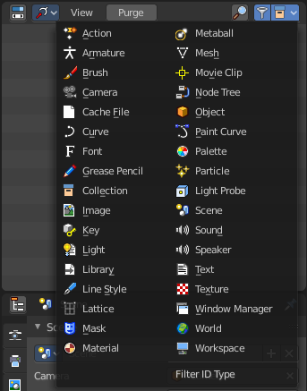
Enable a filter to display a specific data type. You can just filter by one data type at a time. The rest will be hidden.

Filter ID Type
The menu to choose the data type that should be displayed.

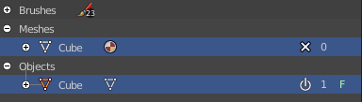
Status column

The number at the right tells you how many users the object has. Objects with a power icon and an F besides the number have a fake user assigned. Objects with an X in the row is orphan data, and will be removed with the next save and reload of the blend file. Objects with the power icon will remain in the scene. They have a fake user.

To remove the Fake User at an object click at the Power icon. It will turn into the X button then. And the object will be removed at saving.

Hotkey only functionality

Important! These hotkeys works with the default Bforartists key map And they do not list the Ndof hotkeys. Ndof is a 3d connexion mouse device that is also used for tablets.
Most of the tools can be found in the graphical UI. But there are still some tools that are hotkey only. Some have a UI brother with equal functionality. For example, Pick shortest path is the hotkey sister of Select shortest path. Some are hotkey only since they cannot be integrated in the graphical UI. Like calling the File menu under the mouse. Or mouse position dependent functionality like selecting an edge loop.
The navigation hotkeys and the context menus are excluded here since they are already covered.

Insert Keyframe - I
Insert a keyframe at current position. You need to have a keying set added to the object.

Delete Keying Set Keyframe - Alt I
Remove existing keyframes.

Hide - H
Hides the object in the 3d view.

Unhide - Alt H
Unhides all hidden objects in the 3d view.

